**Food Security and Agribusiness Track**

The purpose of this track is to analyze the impact of climate change on food security and on agribusiness. The population is growing and according to FAO from United Nations the productivity of the agribusiness sector needs to increase by 70 % for 2050 to be able to feed the earth population. The increase of the productivity has to be sustainable as the impact of agriculture on climate change is important providing more than 25% of GHG emissions.

The track considers one keynote, 3 mini-keynotes and a panel.

**Keynote**

*Title*: Food Security, Climate Change, and Electronics

*Speaker*: Victor Grimblatt, Synopsys

*Abstract*: Current climate change is negatively affecting agricultural production, primarily putting food security at risk in the future and causing substantial economic losses to the agri-food chain. On the other hand, agriculture is impacting the climate change being the responsible of at least one third of the Greenhouse Gases (GHG) emissions and without an important change on the way we produce food this number will continue to increase. Electronics and technology in general can play an important role on the change food production is requesting. The talk will present first the impact of climate change in agriculture, then the impact of agriculture on climate change, and then how technology can help to mitigate it.

Bio: Victor Grimblatt has an engineering diploma in microelectronics from Institut Nationale Polytechnique de Grenoble (INPG – France) and an electronic engineering diploma from Universidad Tecnica Federico Santa Maria (Chile). He got his PhD on Electronics in 2021 from University of Bordeaux. He is currently R&D Group Director and General Manager of Synopsys Chile. He has published several papers in IoT, EDA, Smart Agriculture and embedded systems development. Since 2012 he is chair of the IEEE Chilean chapter of CASS. He has been part of several conferences TCP (ISCAS, ICECS, LASCAS) and Steering Committees. He is member of the IEEE CASS Board of Governors for the period 2021 – 2023. He founded the Electronics for Agrifood SIG at CASS and chairs it. He was Chair of LASCAS Steering Committee from 2018 to 2022. He is CASS representative at the IEEE Climate Change TAB. He was President of the Chilean Electronic and Electrical Industry Association (AIE) from 2017 to 2021. From 2006 to 2008 he was member of the “Chilean Offshoring Committee” organized by the Minister of Economy of Chile. In 2010 he was awarded as “Innovator of the Year in Services Export”. In 2022 he was awarded as “IEEE/AIE Best Engineer” in Chile. In 2023 he was awarded as IEEE R9 Outstanding Engineer” Victor’s research areas are EDA (Electronic Design Automation), IoT, Climate Change, and Smart Agriculture.

*Photo*:

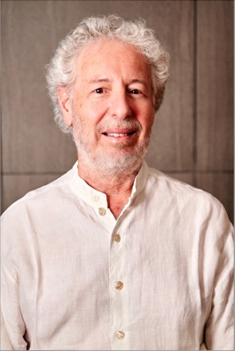

**Mini-Keynotes**

Mini keynote 1

*Title*: “Climate-Smart Agriculture for Environment Care”

*Speaker*: Danilo Demarchi, Politecnico di Torino, Italy

*Abstract*: As reported in the report recently issued by the United Nations (Intergovernmental Panel on Climate Change – IPCC Report 2021), the benefits that technology provides to a green and sustainable economy are highly appreciated and under intense research and development globally. Actual technologies, applied in the domain of Climate-Smart Agriculture (CSA), can bring the needed functionalities and performances for reaching eco-friendly, circular and practical solutions, having as one of the main targets the Food Security. By CSA is possible to obtain more controlled quality production, water use optimisation, and a lower spreading of pesticides and fertilisers, serving the improvement of food quality, but also helping the respect of agriculture for the environment.  
For reaching these targets, electronics are the perfect tool for interfacing the data sources, extracting the data and processing them, and obtaining the needed information along the whole food chain: from the farmer, and the professional stakeholders to the consumers.  
In the keynote talk, an overview of electronics for precision agriculture will be presented, analysing the possible solutions that can bring important innovations, advancing the actual strategies based on remote or indirect measurements, by instead in-place measuring the plant and soil parameters (a.k.a. Let the Plants do The Talking), associated with more standard information derived from environmental conditions. Application scenarios for crop monitoring, water control, information communication and decision support will be presented. In particular, will be analysed technologies for reaching the needed levels of low power and low cost, and the efficient ones to be applied to AgriFood at the global scale, supporting Food Security, Sustainability and Care of the Environment.

*Bio*: Danilo Demarchi is Full Professor at Politecnico di Torino, Department of Electronics and Telecommunications.  
Micro&Nano Electronics, Smart System Integration and IoTs for the AgriFood Value Chain and for BioMedical Devices.  
Visiting Professor at EPFL Lausanne (2019) and at Tel Aviv University (2018-2021). Visiting Scientist (2018) at MIT and Harvard Medical School for the project SISTER (Smart electronic IoT SysTEms for Rehabilitation sciences).  
Author and co-author of 5 patents and more than 300 scientific publications in international journals and peer-reviewed conference proceedings. Leading the MiNES (Micro&Nano Electronic Systems) Laboratory of Politecnico di Torino and coordinating the Italian Institute of Technology Microelectronics group at Politecnico di Torino (IIT@DET).  
Founder and Editor in Chief of the IEEE Transactions on AgriFood Electronics – TAFE. Founder and General-Co-Chair of the IEEE Conference on AgriFood Electronics – CAFE. Founder and Vice-Chair of the IEEE CAS Special Interest Group on AgriFood Electronics. 2023-2024 Distinguished Lecturer for the IEEE CAS Society with the Lecture “Let the Plants Do the Talking: Smart Agriculture by the messages received from Plants and Soil”.  
Member of the IEEE Sensors Council and the BioCAS Technical Committee. Associate Editor of the IEEE Open Journal on Engineering in Medicine and Biology (OJ-EMB).  
General Chair of IEEE BioCAS (Biomedical Circuits and Systems) Conference in 2017 in Torino and founder of IEEE FoodCAS Workshop (Circuits and Systems for the FoodChain). TPC Co-Chair of IEEE ICECS 2019, IEEE BioCAS 2021 and IEEE BioCAS 2022 conferences. General Co-Chair of IEEE BioCAS 2023.  
Organizer of the 3rd Seasonal School on AgriFood Electronics: Smart Technologies for a Sustainable Agriculture in Torino, September 2022.

*Photo*:

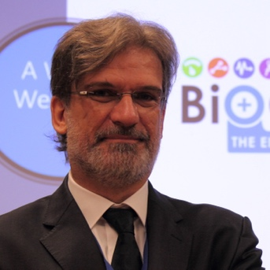

Mini Keynote 2

*Title*: “Adaptation to Agro-Climatic Changes and Food security challenge”

*Speaker*: Kheira ARBAOUI, Universite of Oran, Algeria

Abstract : Water is a vital resource for the demographic and economic development of the world and, at present, has become a rare and precious commodity and constitutes an indispensable vital element for the individual and society. The imbalance between growing demand and reduced supply leads to the problem of water management and scarcity.

Climate change has seriously disrupted the rainfall pattern, affecting the quantity and quality of this resource, leading to water shortages in rain-fed agriculture and is therefore a major threat.

Water use in agriculture has long been characterized by low efficiency due to high losses, and water management as a resource is a key environmental issue, with the consequences of climate change leading to an increased demand of irrigation water which requires an effective methodology for water management.

*Bio*:

Professor Kheira ARBAOUI: PhD in Economics and Management.

Lecturer and researcher at the Faculty of Economics, University of Mohamed Ben Ahmed Oran2.

Member of the MAGHTECH network in charge of scientific projects and activities in Algeria.

Project manager "PRFU" on: Innovative entrepreneurship in the agri-food industry in Algeria : opportunities & risks

My research focuses on Innovation, Knowledge Economy, Food Security, .... In relation to sustainable development and risk management: areas in which I have various works and publications in Arabic, French and recently in English.

*Photo*:

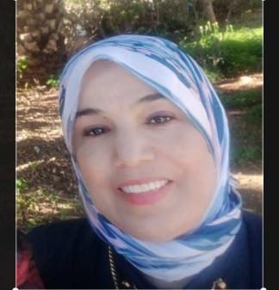

Mini Keynote 3

*Title*: “Reviving Wheatstone Bridge for Accurate Sensing and Mitigating Climate Change: Digital Wheatstone Bridge”

Speaker: Mihai Sanduleanu, Khalifa University of Science and Technology

*Abstract*: In order to make the environment sustainable and mitigate climate change we need to monitor accurately some parameters like temperature, humidity and pressure. The proposed talk caters to this need by using a novel, digital implementation of the classical Wheatstone bridge for resistive sensors. The “de facto” way of measuring a resistance is using calibrated current sources and an A/D converter for measuring the voltage or Wheatstone bridges. Wheatstone bridges require amplifiers for correcting nonlinearity, A/D converters for digitizing the analog output and means for offset correction. Hitherto, the Wheatstone bridge introduces inherent linearity error that renders higher errors in the measurement. Its digital implementation provides an accurate counterpart for increasing accuracy and compactness.

*Bio*: Received his MSc, MEE and PhD degrees from the Technical University of Iasi, Romania, Eindhoven University of Technology, The Netherlands and University of Twente, The Netherlands in 1990, 1993 and 1999, respectively. From 1999 to 2000, he was with Philips Semiconductors, Nijmegen, The Netherlands, working on fiber optic communication circuits. From 2000 to 2007 he joined Philips Research Eindhoven, The Netherlands and he was involved in Fiber Optic Interface circuits, RF IC Design, mm-Waves Transceiver design and Ultra low-power radios. From 2008 to 2013, he conducted research at IBM T.J. Watson Research Center, Yorktown Heights, New York in mm-Waves transceivers for communication, imaging and RADAR and THz electronics. He is currently Associate Professor at Khalifa University of Science and Technology. Dr. Sanduleanu’s area of expertise include Wireless transceiver design for RF/mm-Waves/THz communication, High Speed Communication Circuits for serial I/O, High speed analog-to-digital converters, Phased-Array Systems, High-speed digital circuits and systems. Dr. Sanduleanu authored/co-authored 4 books and more than 89 papers in International Conferences and Journals. He holds 54 US patents. Dr. Sanduleanu served as Associate Editor for IEEE Transactions on Circuits and Systems in 2011-2012.

*Photo*:

